Ameer rhaiby 213932718

Bashar shoumli 318699154

Step 1:

We imported the confusion_matrix from sklearn.metrics and also we learned how to display a matrix with % we ran it twice and here are the results.

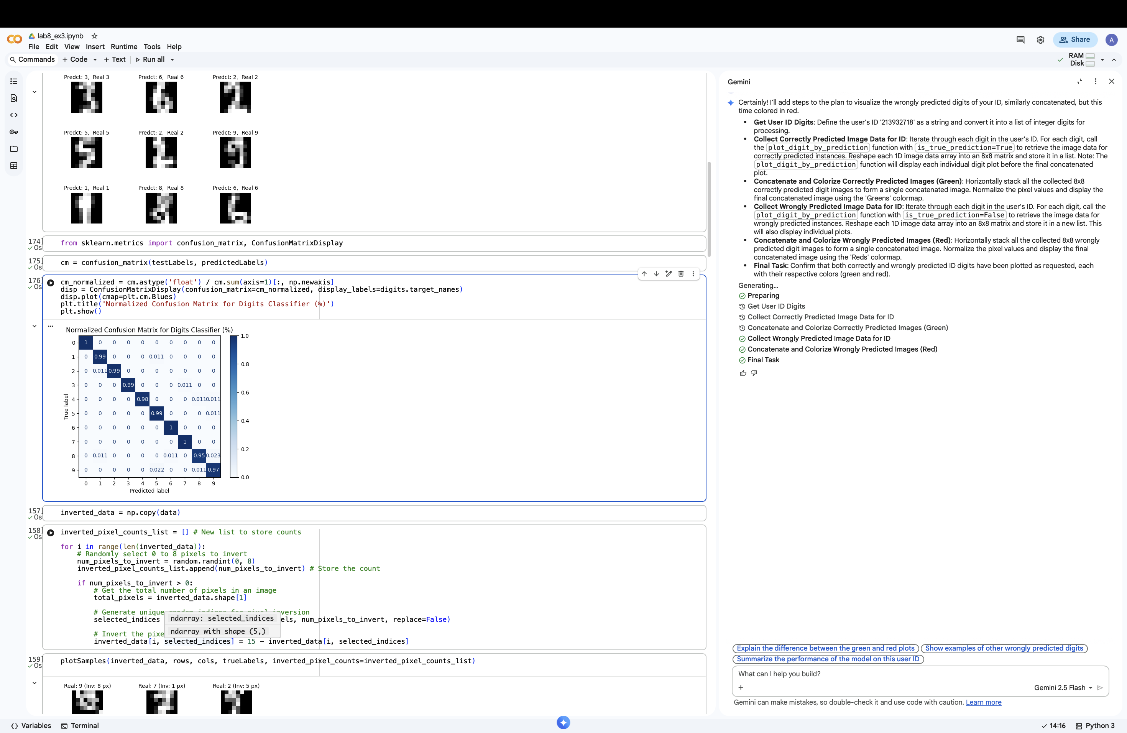

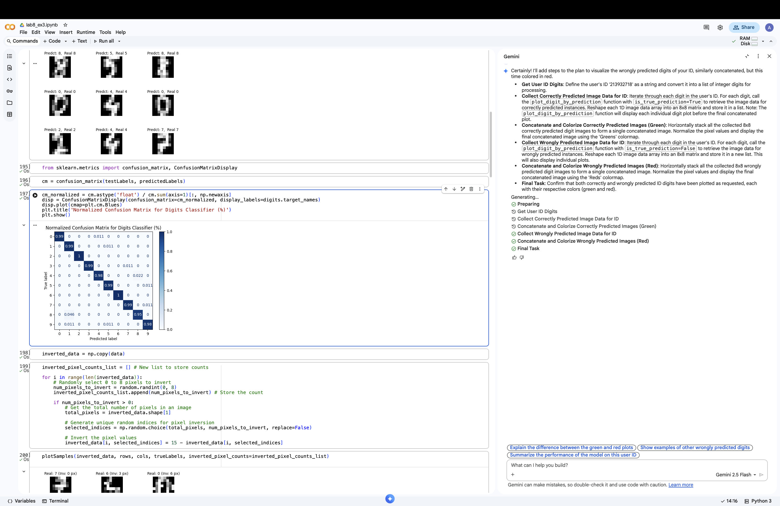

Step 2:

We made a copy of the real data picked a random number from 0-8 and the numerb that we got we chooe a the numbers amount of pixels randomly in our data to invert by reducing it from 15.  
and in the end we display and we can see how some pixels are inverted.

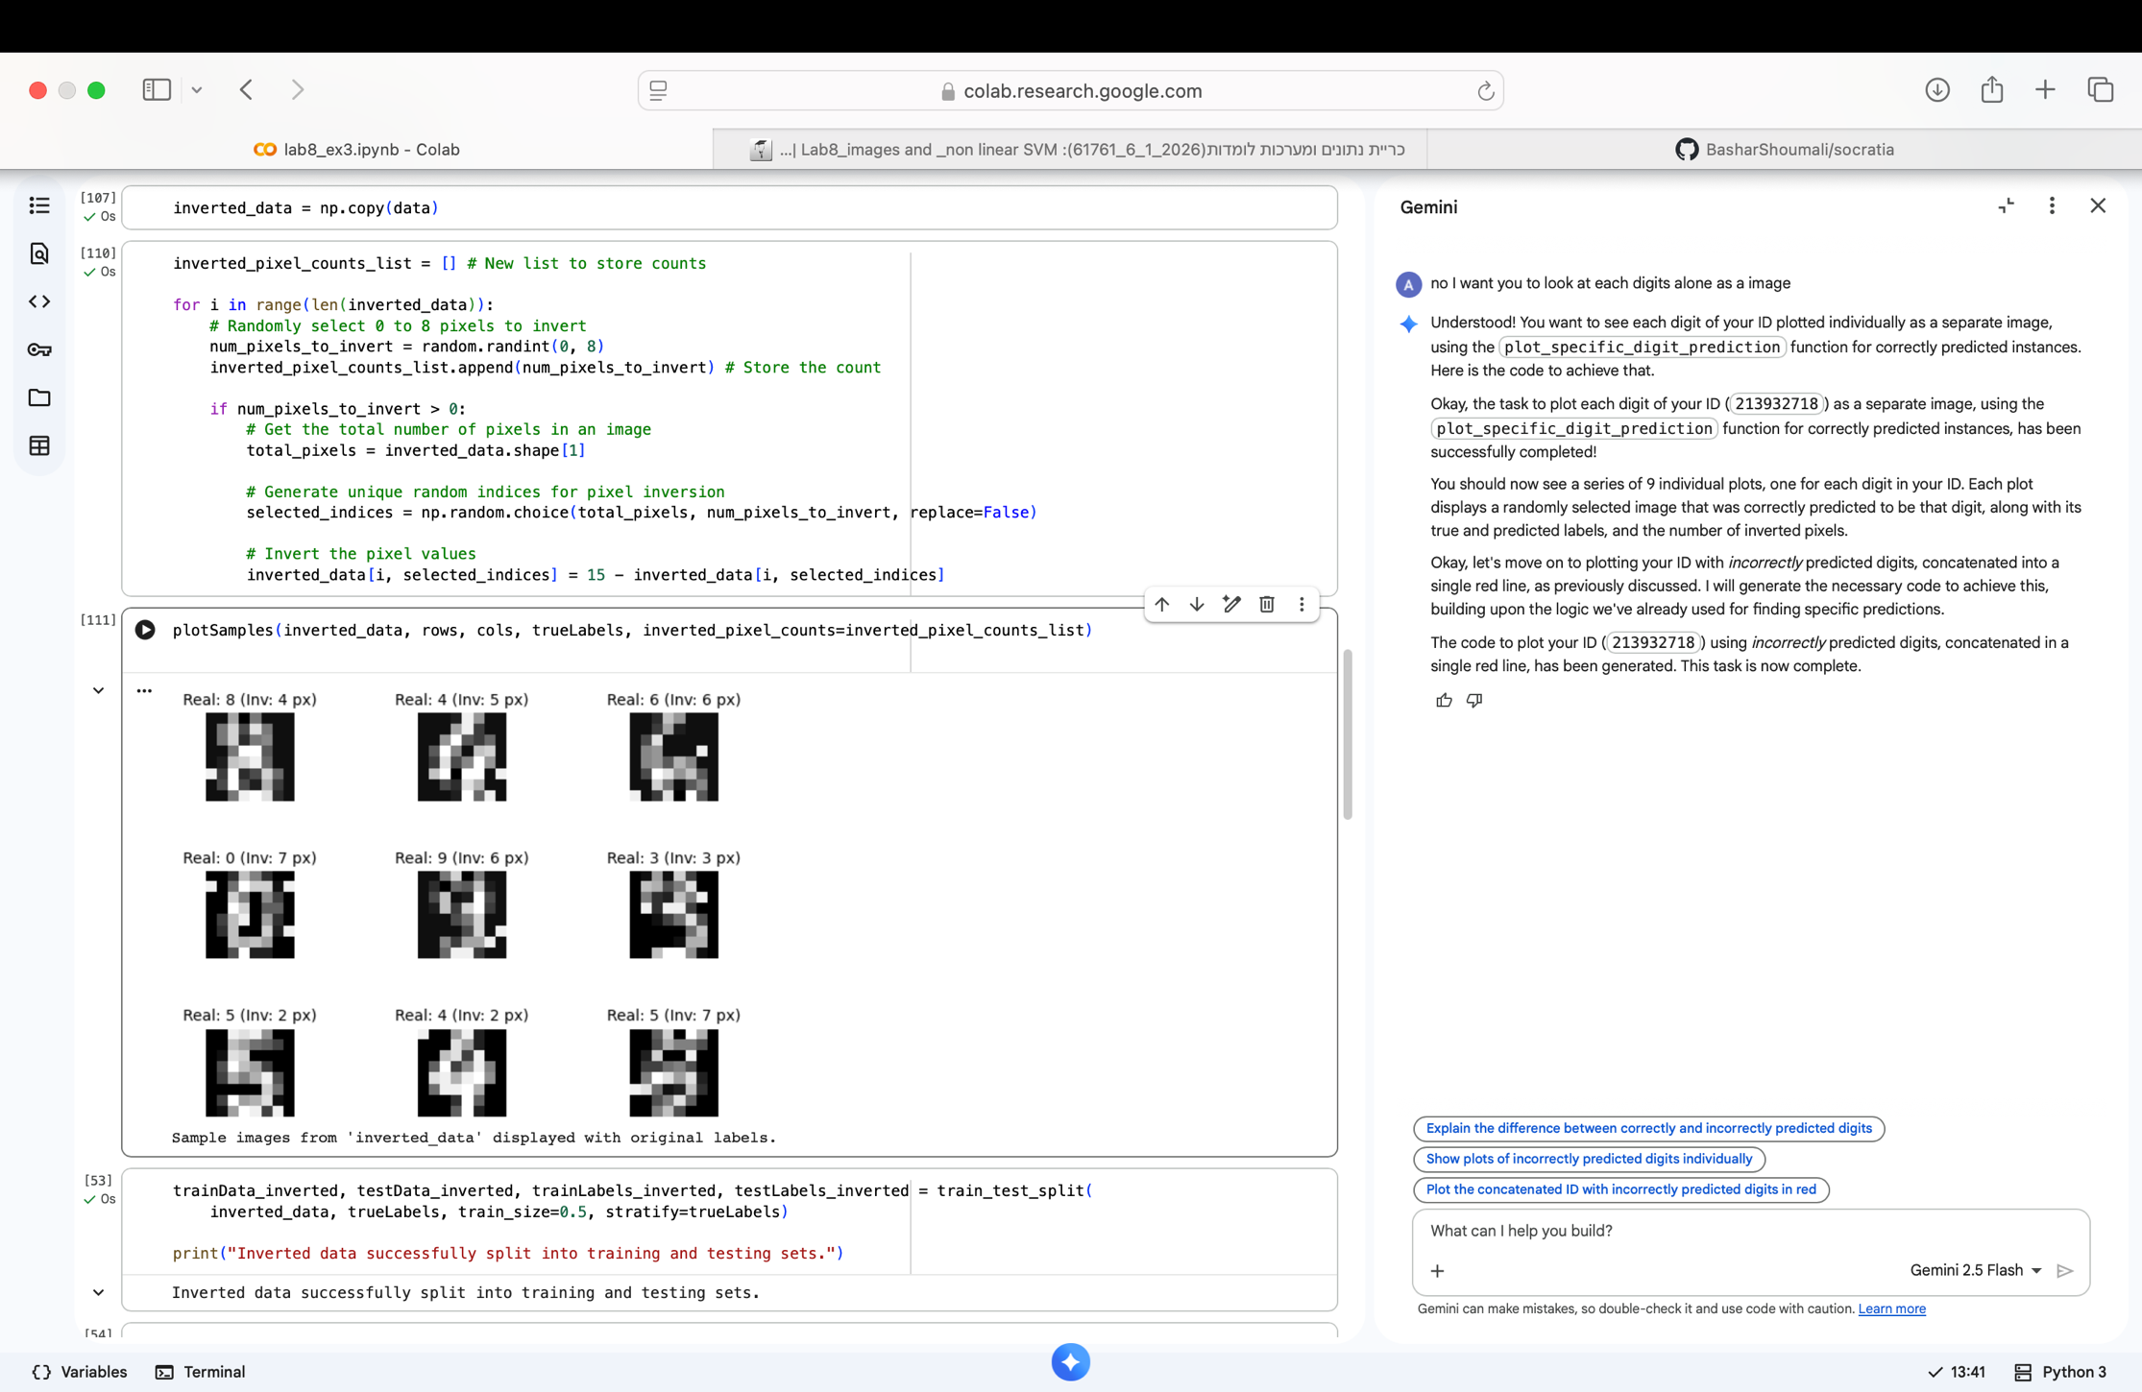

Step 3:

We trained an svm model with the invertedData and the rbf kernel and choose half the data for trainig and other half for testing.  
we can see that we got 2 wrong predictions  
also we made a bigger margin between each number to see the writing clearly.

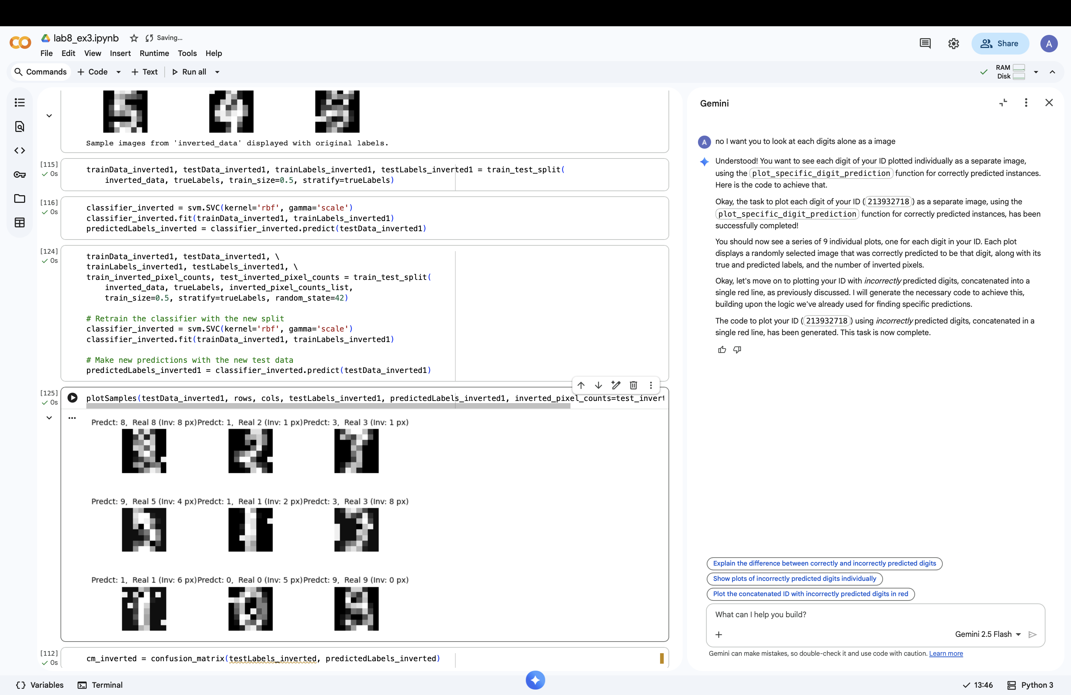

Step 4:

First of all lets explain the result for the first non inverted matrix , we can see that for exqmple the digit 5 95% of the time was classified correctly but 3% of the times were classifies incorrectly as 9.

We can see that the non inverted data is classified better than the inverted data by looking at the confusion matrix which is not a surprise because when we play with the pixles of a number the model will be have more percantage of classifying them as wrong number.

Non inverted inverted

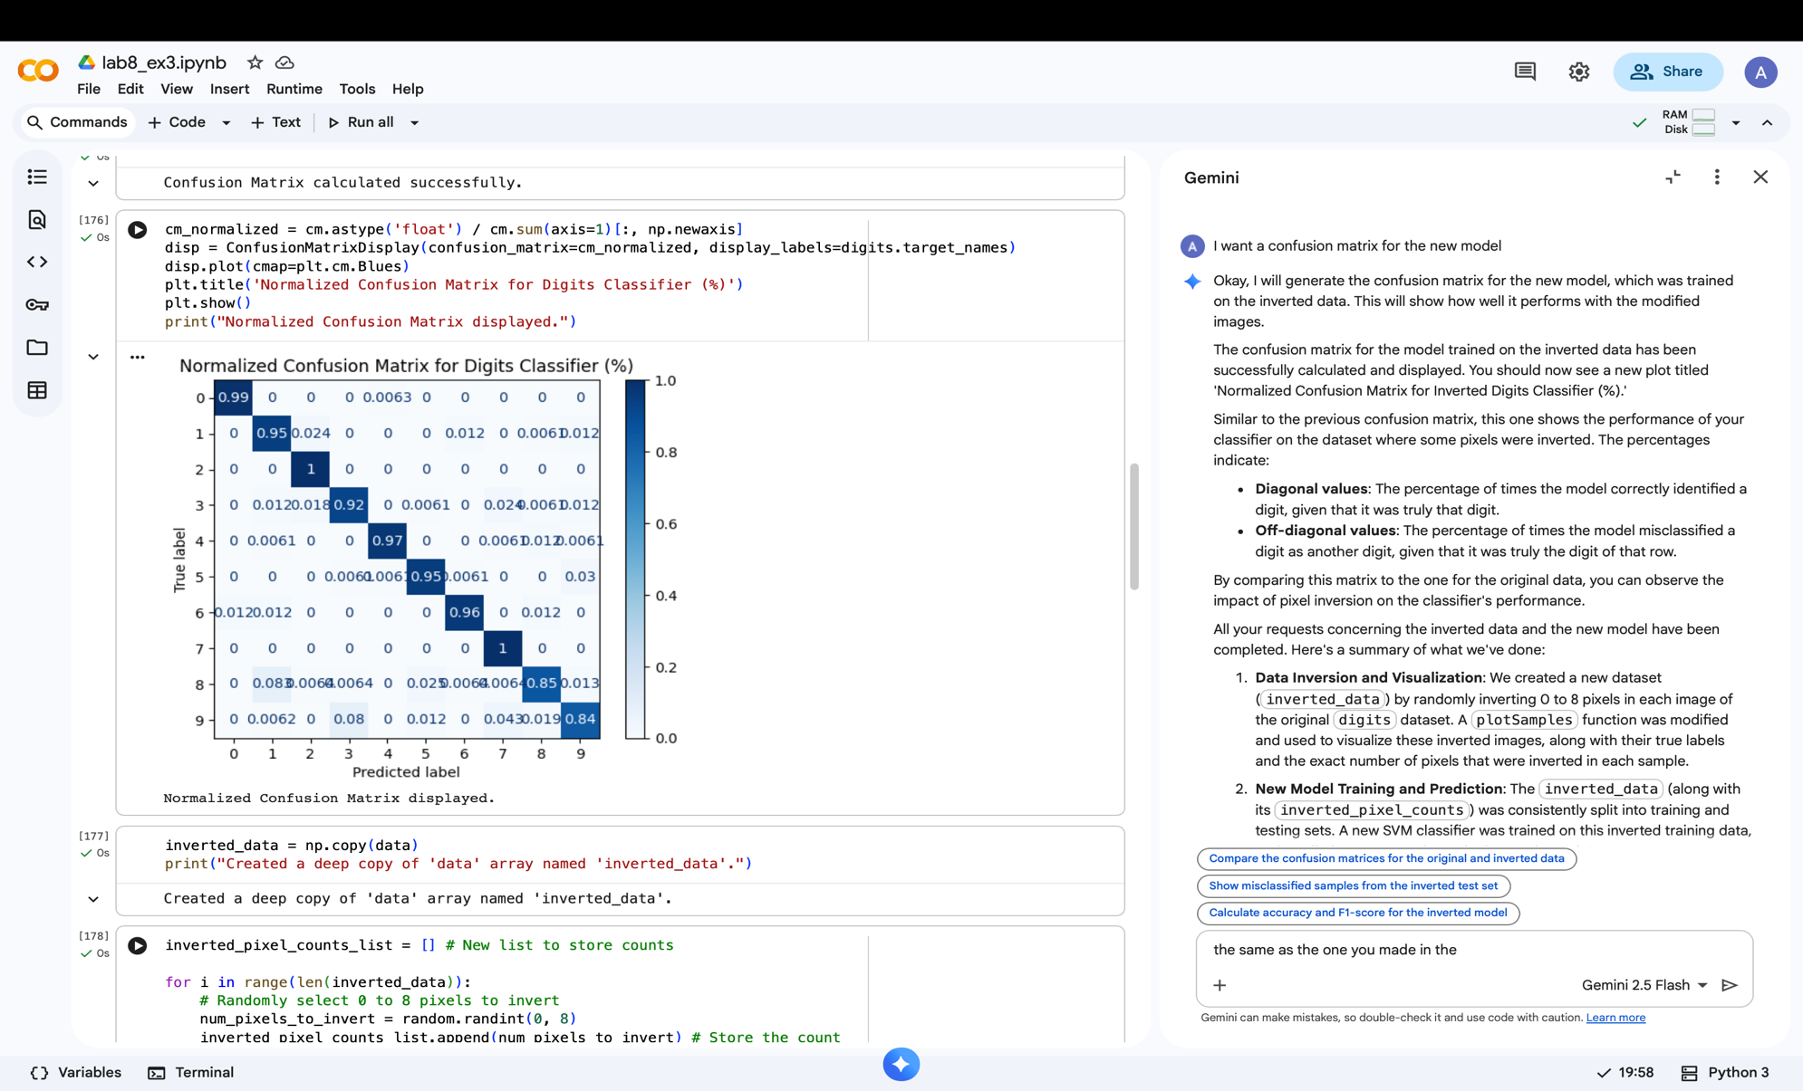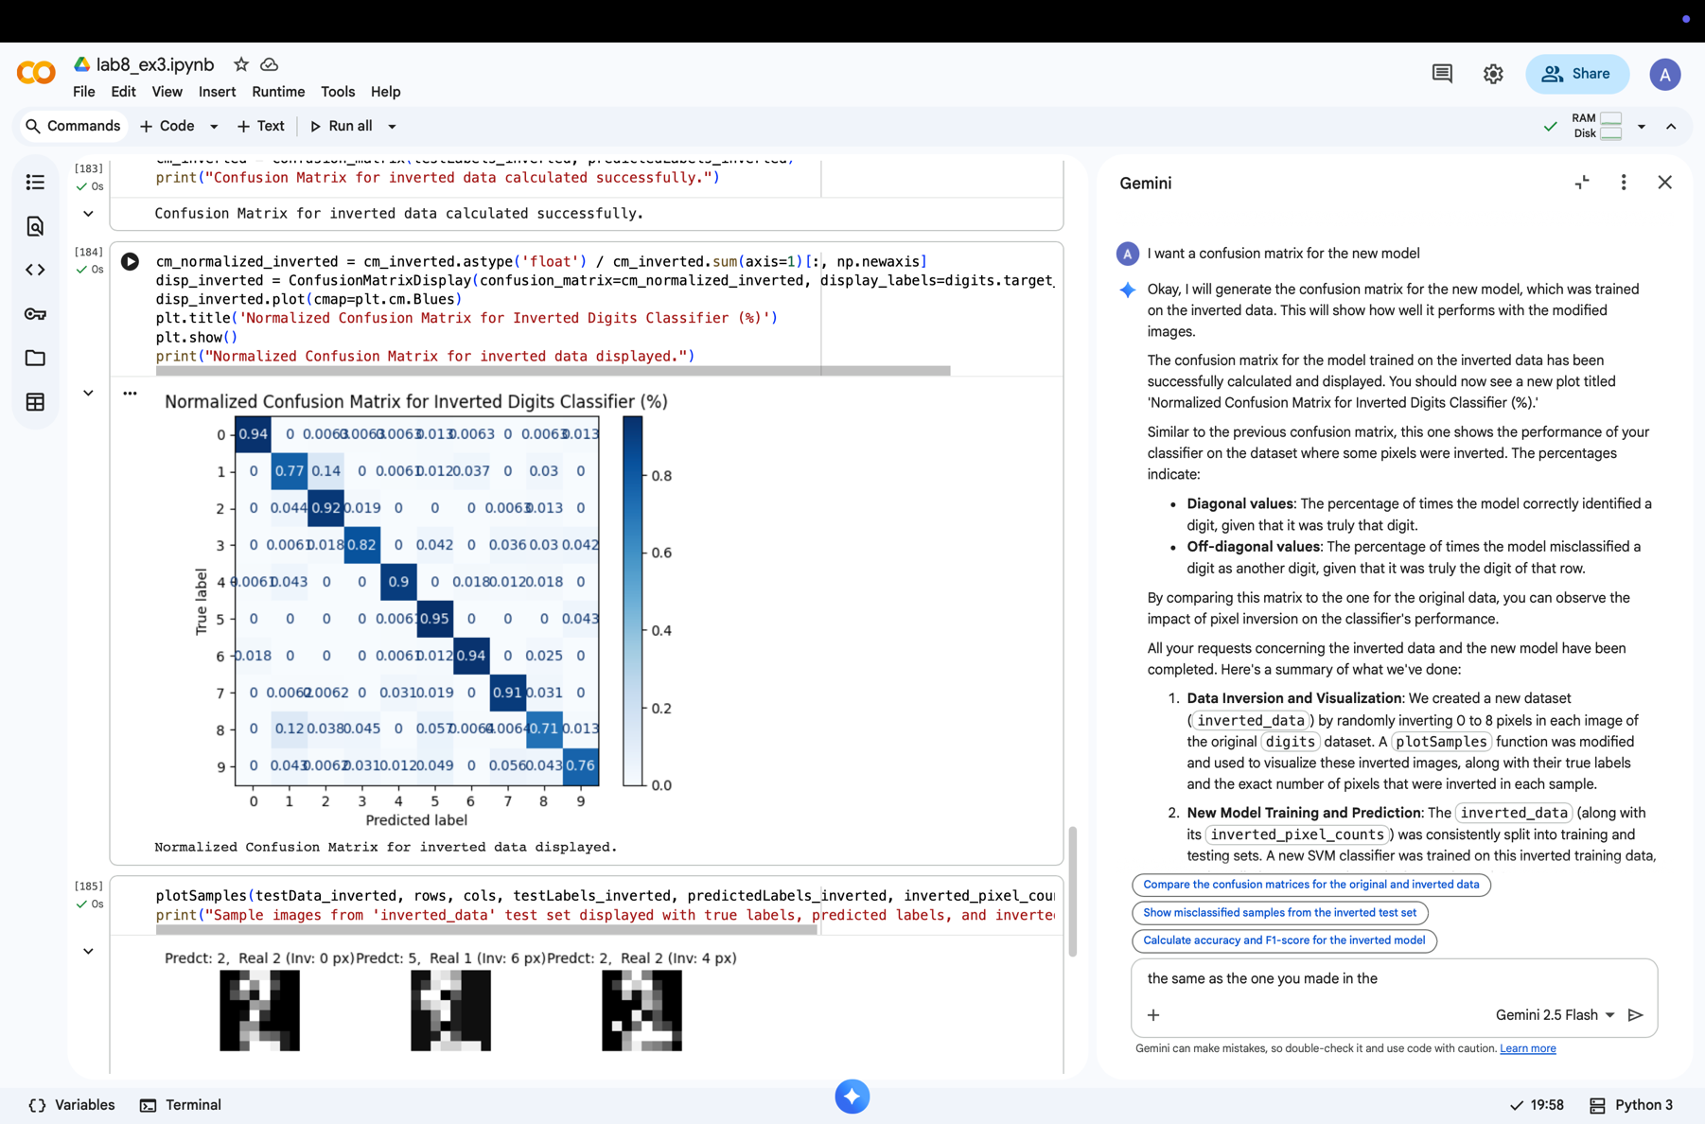

Non inverted

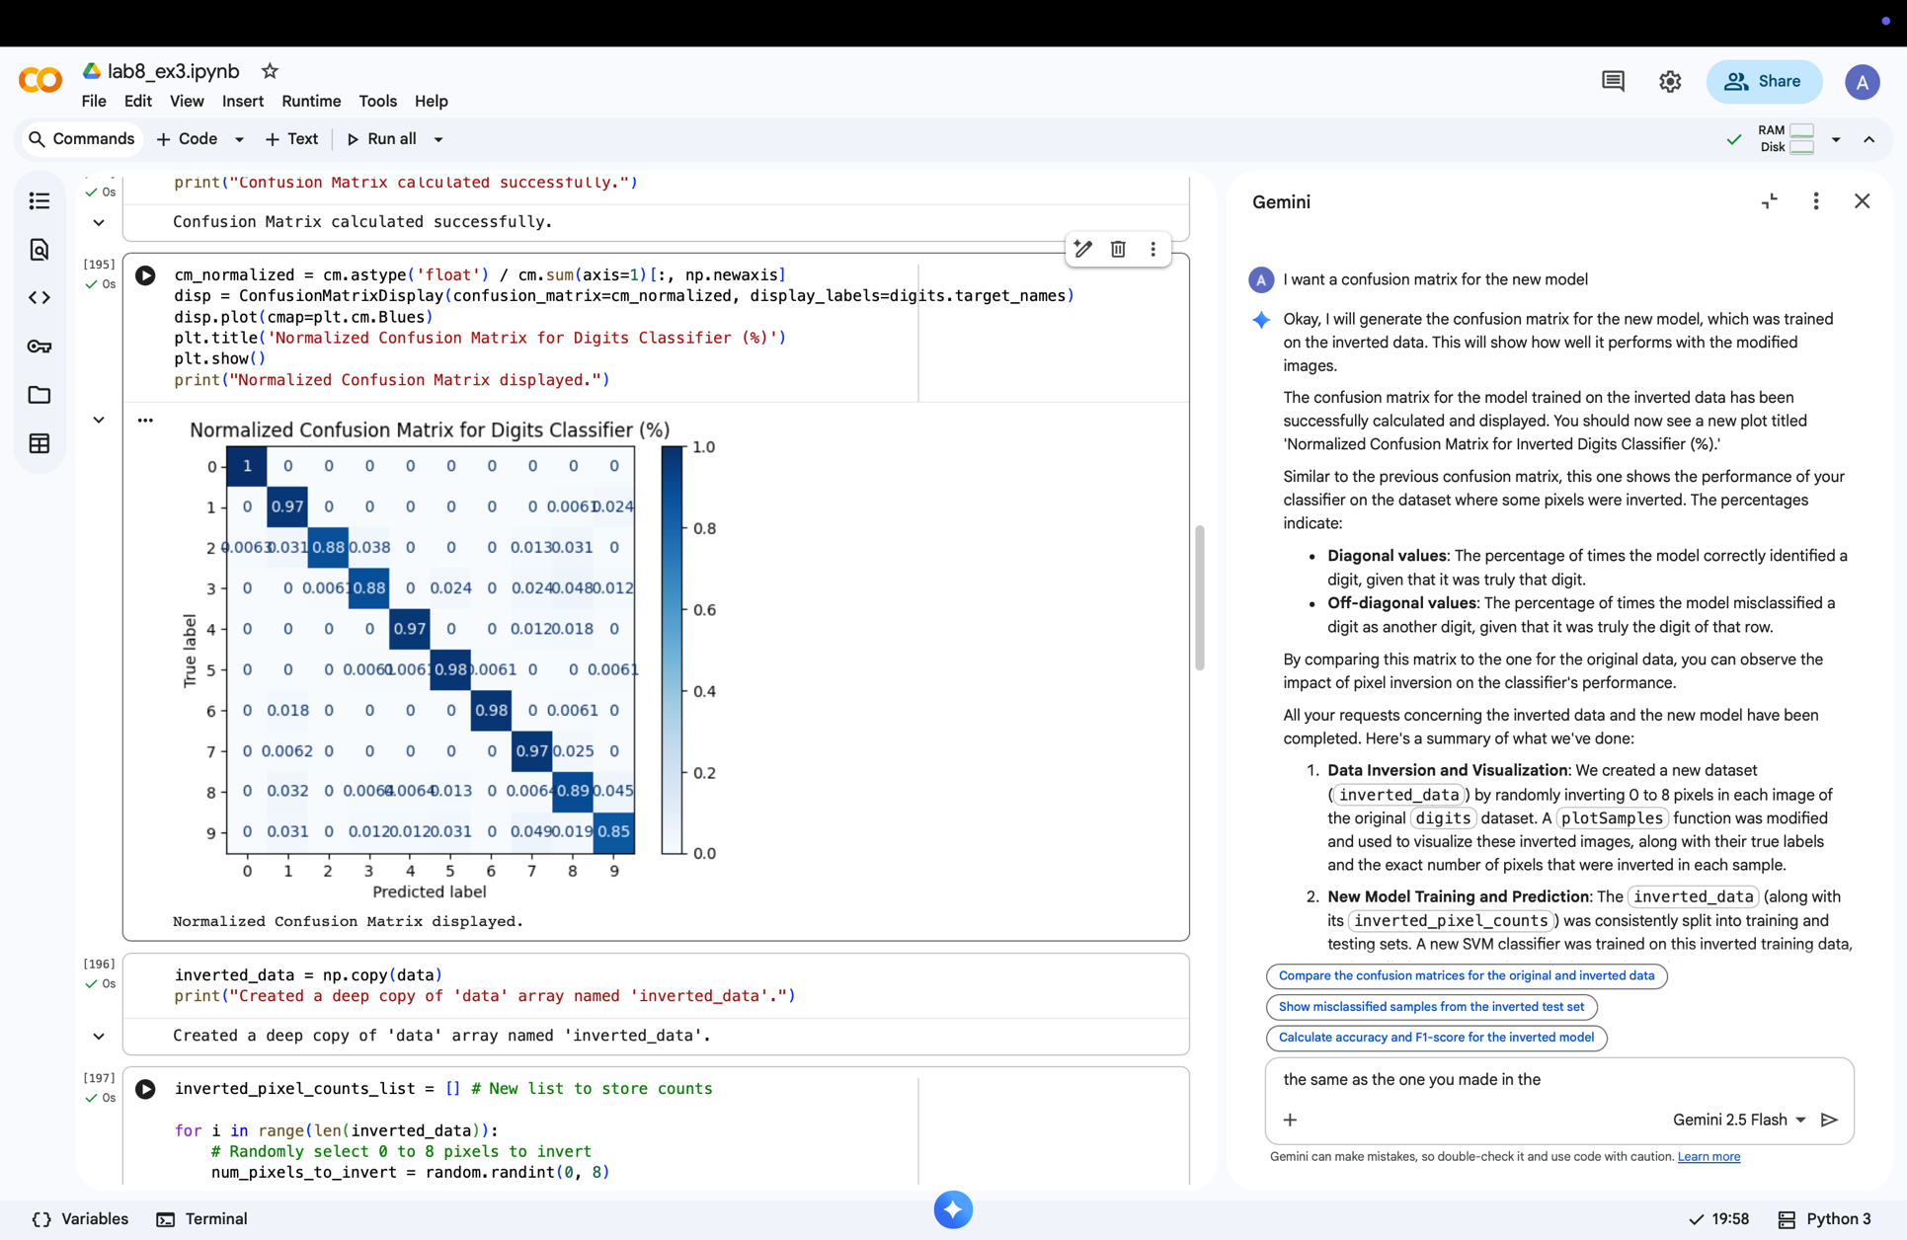inverted

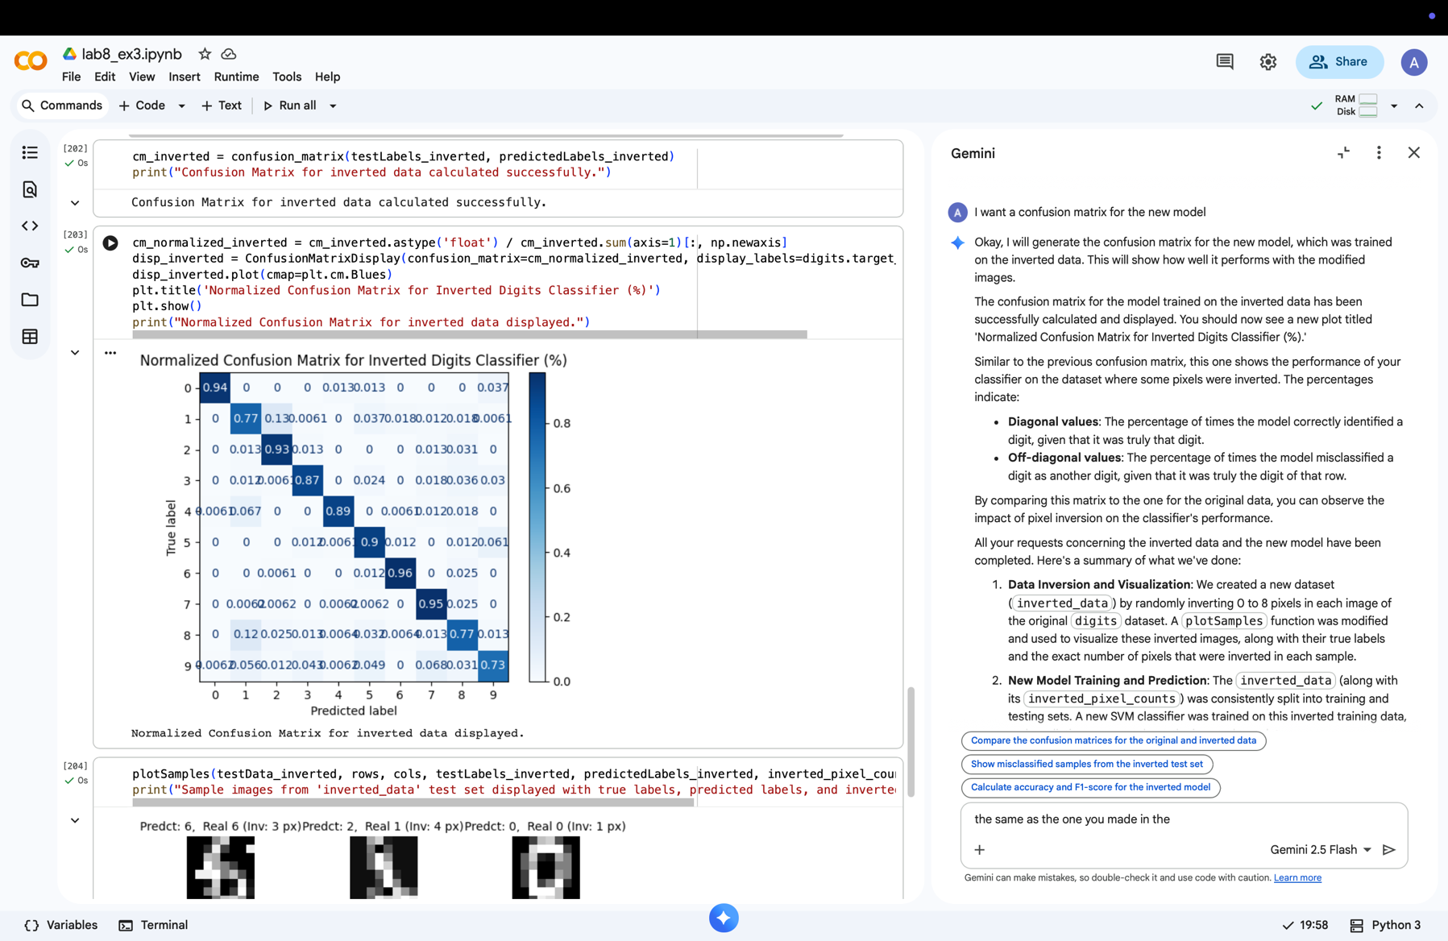

Step 5:

We made a function that recieves a digit and true or false if it gets true it looks for a correctly predicted number that was given , if it gets false it will look for a wrongly predicted number that was given and if it doesn’t foun what we want it will return P=N

We choose the inverted data because we want when we input False to get a lot more results not just P=N .

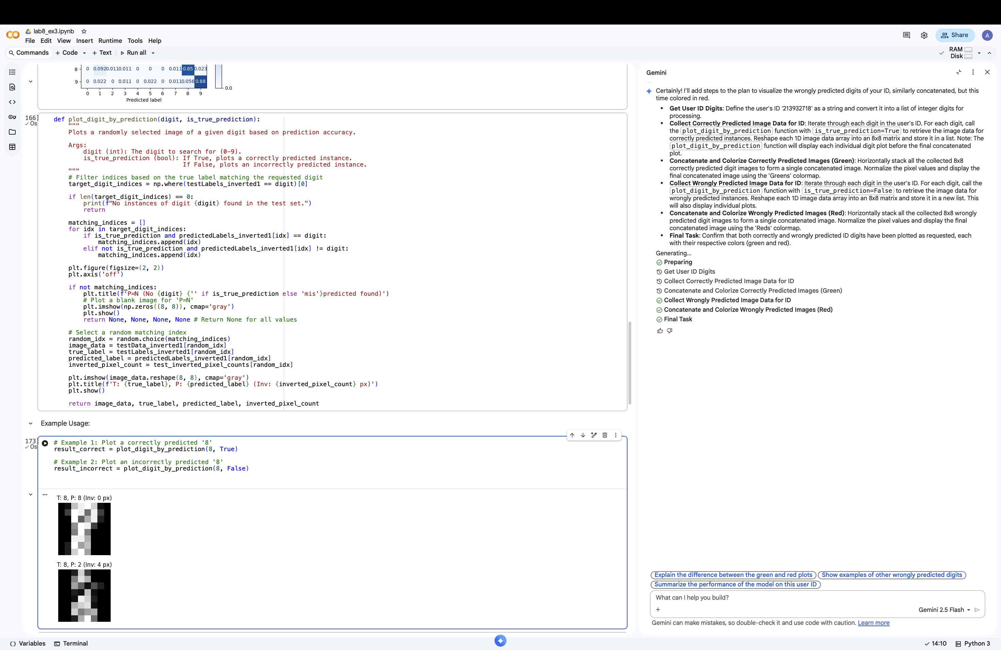

Step 6 :

We put each digit of out id in a list of digits ,by going through each digit we made sure that there are a correctly prediction for each digit of our id .

In the end we made one image of our id with the color green because it is correctly predicted ☺.

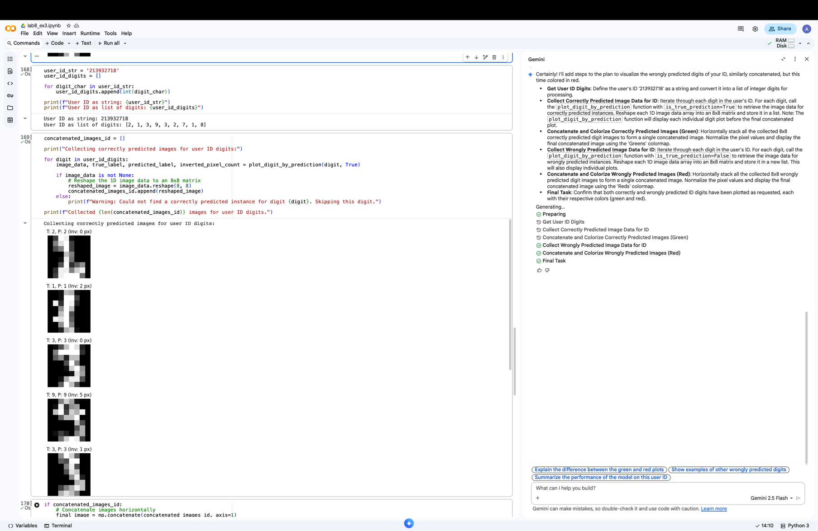

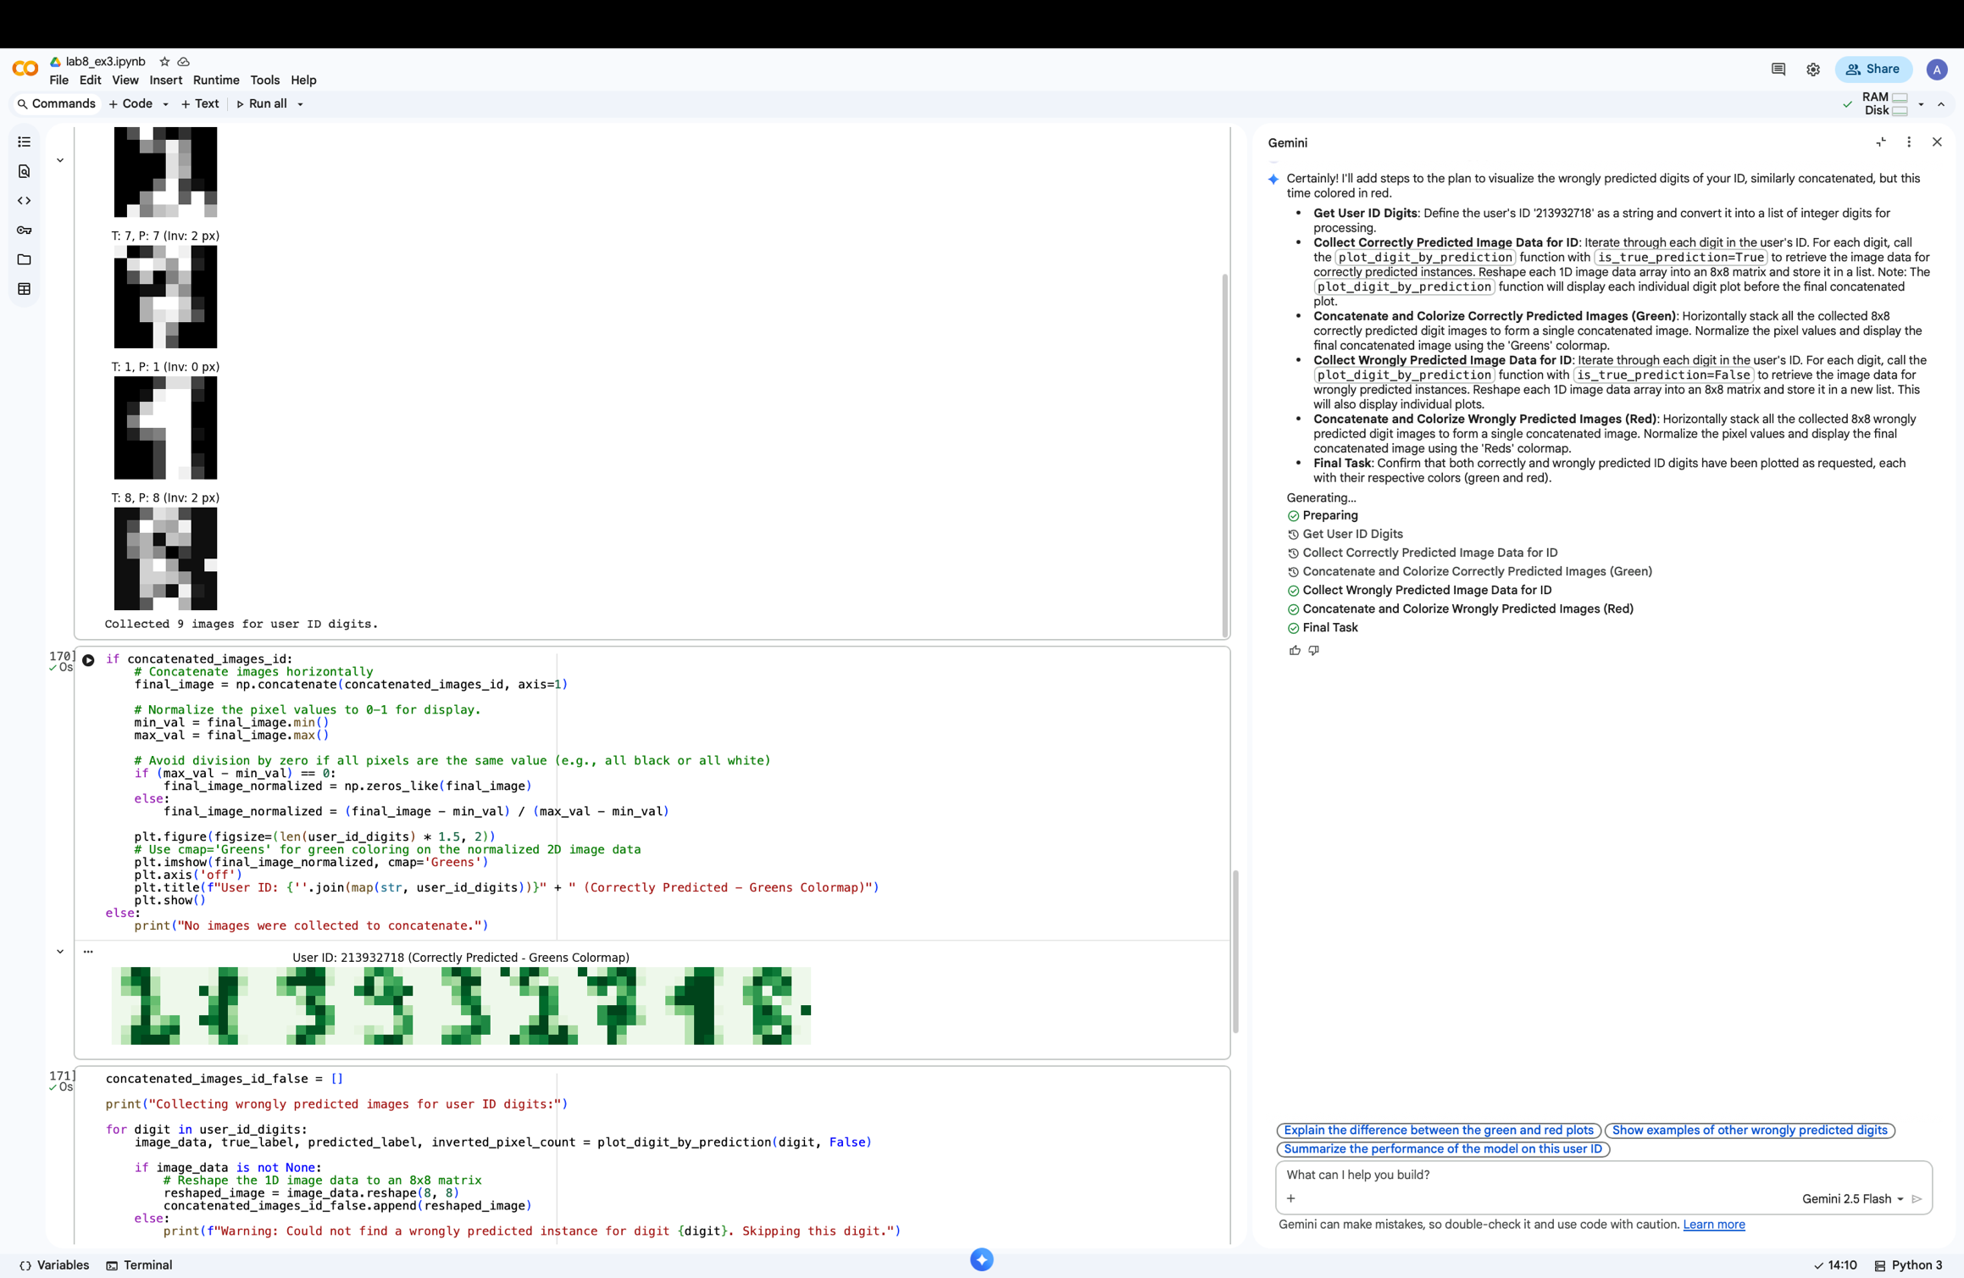

Step 7 :

We put each digit of out id in a list of digits ,by going through each digit we made sure that there is an incorrectly prediction for each digit of our id .

In the end we made one image of our id with the color red because it is incorrectly predicted ☺.

